# VISVESVARAYA TECHNOLOGICAL UNIVERSITY

**“Jnana Sangama”,** Belagavi-590018, Karnataka



## Technical Seminar Synopsis on

## Personality-Aware Product Recommendation System

## Submitted by

**USN Name**

## 1BI19CS054 G R Preetham

Under the Guidance of

**Prof. Pooja P.**

Assistant Professor Department of CSE, BIT Bengaluru-560004



**DEPARTMENT OF COMPUTER SCIENCE & ENGINEERING**

# BANGALORE INSTITUTE OF TECHNOLOGY

K.R. Road, V.V.Pura, Bengaluru-560 004

**2022-23**

# Introduction

## Domain knowledge

Recommendation systems are frequently preferred in recent years ensuring customer satisfaction and accelerating sales. Thanks to these systems, it is aimed to accelerate the decision-making process of customers. Recommendation systems have become a necessary part, especially in online shopping. Most of the recommendation systems used in many different areas have been attracting attention, focusing on fashion, and clothing recently.

## Motivation

Data mining, also known as knowledge discovery in data (KDD), is the process of uncovering patterns and other valuable information from large data sets. The proposed system was compared against recent recommendation methods, such as deep-learning-based recommendation system and session-based recommendation systems. Experimental results show that the proposed method can increase the precision and recall of the recommendation system, especially in cold-start settings. Due to the recent developments in internet technologies, online shopping continues to grow rapidly. Customers prefer to purchase new products in colour or pattern to be compatible with existing products. In online shopping, it takes a lot of time to search for all compatible products. Automated recommendation systems can speed up finding a wide variety of patterns that customers are interested in. The use of recommendation systems is increasing day by day, as it helps consumers effectively scan a huge number of products online and identify the right products that meet their needs.

## Objectives

1. To incorporate the user’s personality traits to predict his/her topics of interest and to match the user’ personality features with the associated items.
2. To recommend a product even if the user’s history does not contain these items or similar ones based on user’s topical interests.
3. To build an efficient and faster recommendation system.

# Literature Review

* [Yan Fang](https://ieeexplore.ieee.org/author/37407430000), at al., [1] customized bundle recommendation method is proposed for online supermarket in this research. It is realized by combinational using association rule mining, customer segmentation and recommendation techniques. The association rules of product category are used to avoid mass unnecessary association rules of product. The product lists recommended within each category are generated by product ranking on each customer segmentation.
* [Chantima Buaklee](https://ieeexplore.ieee.org/author/37086808062), at al., [2] we studied the correlation of purchasing histories and the customer’s interests on social network (Facebook) to predict the future interests of customers that would show through social network. In addition, we use the data to find more similar target group of customers who are also interested in the same category of product by text analysis with Facebook Pages Liked. We focus on the product categories aligned by the shopping online websites and find the customer cluster which is similar with the customer who purchased.
* [R.V. Karthik](https://ieeexplore.ieee.org/author/37086511297), at al., [3] proposed algorithm analyzes online products and ranks them according to product reviews. Finally, it recommends the suitable product to the target customers. Experiments have been conducted using online reviews for evaluating the proposed algorithm and found that the proposed recommendation algorithm achieves better prediction accuracy than the exiting classifiers such as Naïve Bayes, Support Vector Machine, Random Forest, Decision Tree and K-NN.
* [Ni Made Satvika Iswari](https://ieeexplore.ieee.org/author/37085359078), at al., [4] the Slope One algorithm is used where the input rating is given based on the domain ontology of the product. Domain ontology is used to represent relationships between products. Thus, the product recommendations are expected to be in accordance with the user's interest. So that product sales are right on target and users get products that suit their needs. This recommendation system will be implemented on e-commerce platforms and is expected to help users and sellers.
* [Terutaka Yoshikawa](https://ieeexplore.ieee.org/author/37088212631), at al., [5] we described the complaint information extraction based on product review analysis by extracting both negative information and positive information from product reviews, and we also explain alternative product recommendation method that can solve complaints, and we verify the effectiveness of complaint information extraction and alternative product recommendation.
* [Umit Turkut](https://ieeexplore.ieee.org/author/37088452585), at al., [6] A deep learning-based online recommendation system has been proposed with a Convolutional Neural Network (CNN). Classes of different patterns in the CNN architecture have been determined according to users' and designers' pattern preferences. The deep learning model recommends patterns considering color compatibility for textile products.
* [Keerthika K](https://ieeexplore.ieee.org/author/37088802688), at al., [7] The diversity of user demographic in social network makes the recommendation system can be applied to introduce variety of product recommendation. The seasonality of product is emerging trend in recommendation system to actively seek out the right product at right time. The work focuses on investigating the efficiency of recommender system, in generating the diverse suggestions for E-commerce dataset.
* [Okfalisa](https://ieeexplore.ieee.org/author/38257718800), at al., [8] It provided an optimal online shop recommendation as an alternative solution. The Decision Support System (DSS) approach on management model applied Multi-Objective Optimization on the Base of Ratio Analysis (MOORA) for the analytical calculation by considering several criteria, including price, rating, discount, a product sold, and response chat. It reveals the ranking of fifty online shops in the marketplace as the maximum alternatives' product recommendations.
* [Dimas Indiarto Sumiko](https://ieeexplore.ieee.org/author/37088571809), at al., [9] The questionnaired is used as an instrument for data collection. Respondent who were included in this study are 338 Youtube users in Indonesia who watched ‘GadgetIn’ Youtube channel at least in last year. Data is processed using the Structural Equation Modeling (SEM) method and using Lisrel 8.0 software. The result of the study concluded that certain signals characteristics have an effect on trust in recommender and product affection in order to create an impulsive buying behaviour of customers.

# Limitations of Existing System

1. The existing system is content based recommendation system, which is not efficient and doesn’t recommend appropriate products to new users.
2. The time taken to recommend products is more.
3. There is existence of language barrier in the current system.
4. The products recommended are not related to the searched product.

# Proposed System

# The proposed system is personality-aware from two aspects; it incorporates the user’s personality traits to predict his/her topics of interest and to match the user’s personality

# facets with the associated items based on a hybrid filtering approach Collaborative Filtering and Content Filtering or Content-Based Filtering (CF and CBF) and personality-aware interest mining. The purpose of Meta-Interest is to recommend the most relevant items by detecting the user’s topical interests from its social networking data and the relationship between the users and products is predicted using a graph-based meta path discovery.

# Architecture

# 

Figure 1: Meta-Interest recommendations process

Figure 1 shows the general system framework of Meta-Interest. The recommendation process includes five steps. Step 1 is the personality traits’ measurement, which can be obtained by asking the user to take a personality measurement questionnaires. Step 2 is mining the user’s topical interests, including explicit and implicit interest mining. In Step 3, Meta-Interest matches the items with the corresponding topics. In Step 4, the set of most similar users (neighbours) to the subject user is determined. Finally, Step 5 is the item recommendation phase, and the recommendation is refined by updating the neighbours’ set and the user’s topical interest profile and topics–items matching.

# Methodologies/Algorithms

# Algorithm 1 shows the pseudocode of interest mining steps.

# Algorithm 2 shows the pseudocode of the item interest mapping process. With newly added items that have not been viewed by any user.

# Algorithm 3 presents the steps of metapath discovery. The algorithm takes as input the user

# source node us , the maximum metapath length to explore lmax, and the link prediction score threshold.

# Algorithm 4 shows the pseudocode for Recommending similar products.

# 

# 

# 

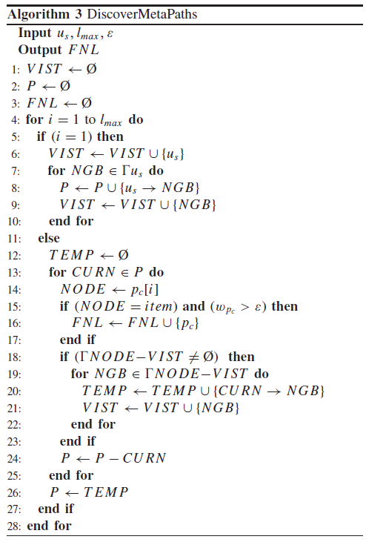

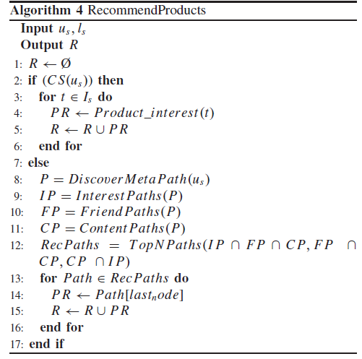

# Applications

* + 1. Enterprises can use our hybrid recognition and recommendation system to increase their sales volumes.
    2. Providing feasibility and accuracy in the retail market, because inaccurate recommendations can produce a negative impact on a customer.
    3. Time series analysis and accurate categorization of product images based on the variation in color, trend and clothing style in order to develop an effective recommendation system.
    4. Providing a universal recommendation system by eliminating language barrier.

# References

# [1] Yan Fang, Xinyue Xiao, Xiaoyu Wang, Huiqing Lan, “Customized Bundle Recommendation by Association Rules of Product Categories for Online Supermarkets,” 2018 IEEE Third International Conference on Data Science in Cyberspace (DSC).

# [2] Chantima Buaklee, Sukree Sinthupinyo, “Similar Cluster recommendation of Product

# Purchases by Pages liked Analysis,” 2018 10th International Conference on Electronics, Computers and Artificial Intelligence (ECAI).

# [3] R.V. Karthik, Sannasi Ganapathy, Arputharaj Kannan “A Recommendation System for Online Purchase Using Feature and Product Ranking,” 2018 Eleventh International Conference on Contemporary Computing (IC3).

# [4] Ni Made Satvika Iswari, Wella Wella, Andre Rusli, “Product Recommendation for e-Commerce System based on Ontology,” 2019 1st International Conference on Cybernetics and Intelligent System (ICORIS).

# [5] Terutaka Yoshikawa, Yuanyuan Wang, Yukiko Kawai, “A Product Recommendation System Based on User Complaint Analysis Using Product Reviews,” 2019 IEEE 8th Global Conference on Consumer Electronics (GCCE).

# [6] Umit Turkut, Adem Tuncer, Hüseyin Savran, Sait Yılmaz, “An Online Recommendation System Using Deep Learning for Textile Products,” 2020 International Congress on Human-Computer Interaction, Optimization and Robotic Applications (HORA).

# [7] Keerthika K, Saravanan T, “Enhanced Product Recommendations based on Seasonality and Demography in Ecommerce,” 2020 2nd International Conference on Advances in Computing, Communication Control and Networking (ICACCCN).

# [8] Okfalisa, Zulfahri, Dwi Utari Iswavigra, Megawati, Saktioto, “Online Shop Recommendations: Decision Support System Based on Multi-Objective Optimization on the Basis of Ratio Analysis,” 2020 8th International Conference on Cyber and IT Service Management (CITSM).

# [9] Dimas Indiarto Sumiko, Anna Amalyah Agus, “The Effect of Product Recommendation in Youtube To Consumer Impulsive Buying Of Smartphone Product,” 2020 3rd International Conference on Computer and Informatics Engineering (IC2IE).